Instructions for the use of external lithium batteries
1. Connect the inverter to the lithium battery with reference to the manual.
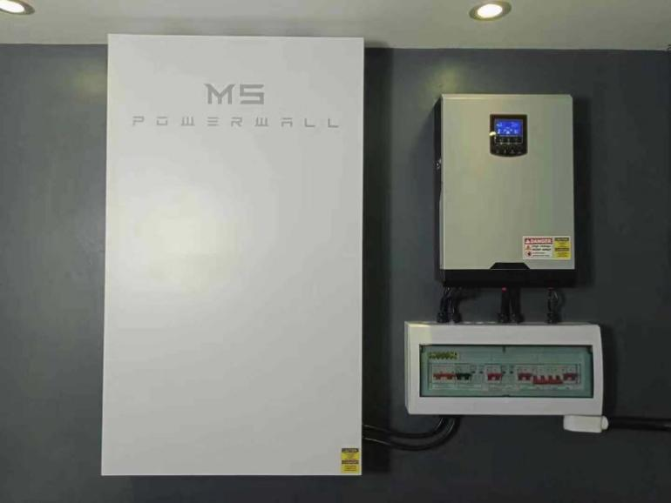
2. Please confirm the following battery package parameters.
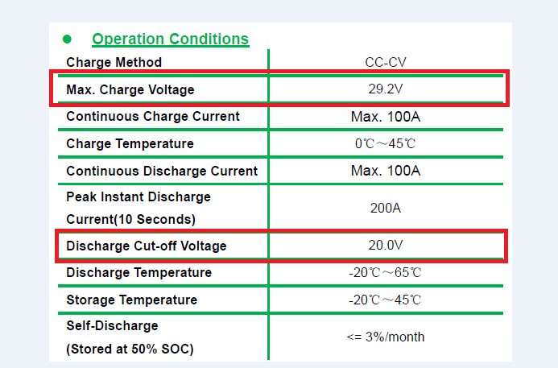
3. Make sure all wiring is correct and turn on， Enter the LCD setup interface.
4. Setting method：
4.1 Frist Seting the 05 items and select the battery type to be USER

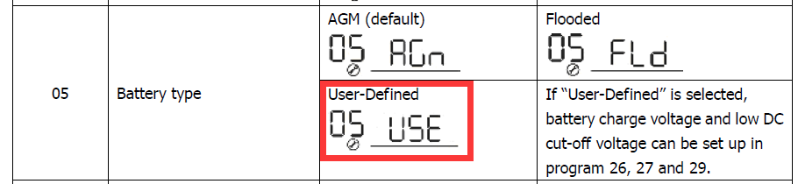
4.2 The second part is seting with 27 items：Floating charging voltage.
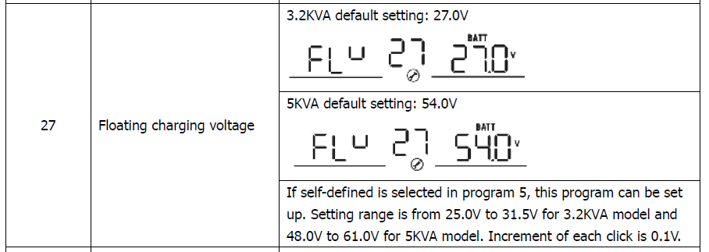
NOTE：The floating charge voltage setting point needs to refer to the Max charge voltage in the lithium battery package parameter table，The fixed point of floating charging voltage is 0.3 V —0.5V lower than the maximum charging voltage. For example, the maximum charge voltage is 29.5 V, then the floating charge voltage is recommended to be 29.0 V.
This is not required if the maximum charge voltage for the battery pack is higher than the inverter float charge maximum voltage 0.5V.

4.3 The third part sets the Low DC cut-off voltage.
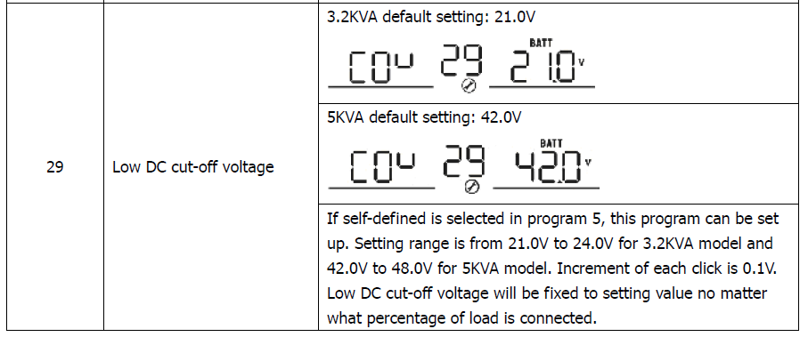

NOTE：The Low DC cut-off voltage must be greater than the Discharge cut-off of the lithium battery pack，Recommended 0.5 V higher. For example, The Discharge cut-off voltage of lithium battery package is 21.0V, and it is suggested that the Low DC cut-off voltage of inverter should be 21.5V.
This is not required if the voltage Discharge cut-off of the lithium battery pack is less than the low DC cut-off voltage of the inverter for more than 0.5 V.

